Reflux Symptom Index
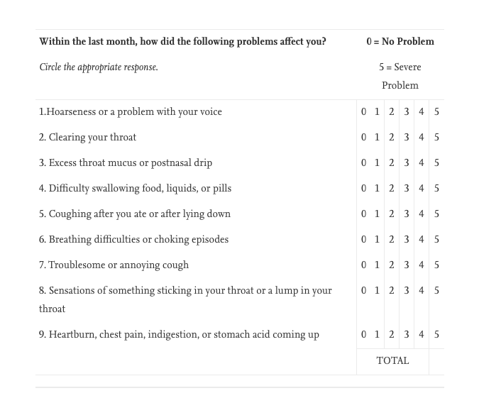
A score of >13 is considered to be abnormal.

